BRIXHAM HERITAGE SAILING REGATTA
25th – 26th May 2019
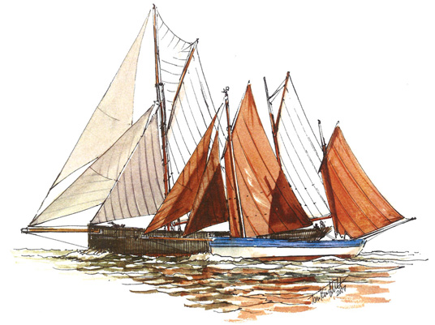
This wonderful event is the true start of the classic sailing season along the South West Coast. See Torbay covered in classic sail – quite a sight!
On Saturday 25th May the Brixham Heritage Regatta Committee, together with Brixham Yacht Club, invite entrants to our traditional fish pie supper and sea shanties evening. On Sunday 26th May all the boats start the Parade of Sail from Brixham Harbour at 11.30 and then follow on with the Regatta being led out by the Brixham Trawlers at 12.45. Good viewing from the Breakwater and Battery Point.
Very few restrictions on participating boats, simply be of heritage design, or a classic yacht, a dinghy or working boat over 30 years old. Torbay Harbour Authority is generously offering free berthing to participants along the Heritage Pontoon for the nights of 24/25/26th May.
Have a look at our website brixhamheritageregatta.uk for more details and entry forms and don’t hesitate to get in touch for further details.
P.S. Don’t forget the Heritage Regatta’s bookend to South West Sailing Season: The Brixham Heritage Rally 7th September 2019

